Notes for Healthcare Project

Centers for Medicare & Medicaid Services

<https://www.cms.gov/marketplace/resources/data/public-use-files>

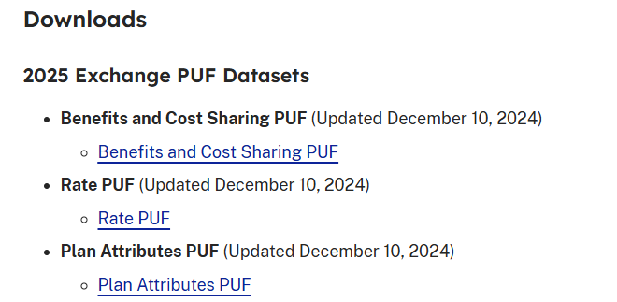

<https://www.cms.gov/data-research/statistics-trends-reports/marketplace-products/2024-marketplace-open-enrollment-period-public-use-files>

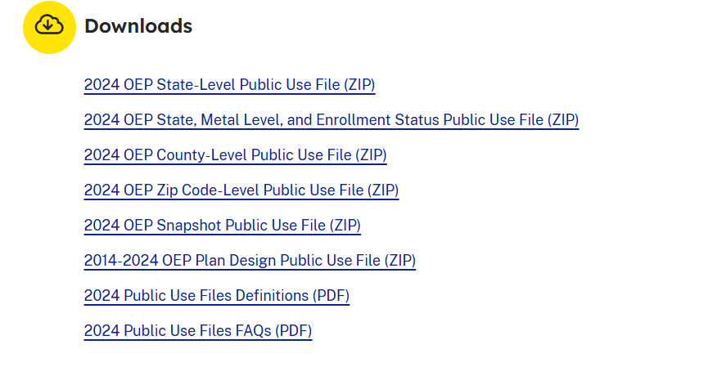

1. **2024 Marketplace Open Enrollment Period PUFs**

**Focus:**

* **Latest annual data** on **Marketplace open enrollment** (2024).
* Tracks **who enrolled**, **what plans they chose**, and **how much they paid** during **open enrollment**.
* **Best for trend analysis** on insurance adoption & affordability.

**Key Datasets Here:**

* **State-Level PUF** – Enrollment totals & plan selections by **state**.
* **County-Level PUF** – More detailed breakdowns at the **county level**.
* **Zip Code-Level PUF** – Granular data on **local enrollment trends**.
* **Metal Level PUF** – Enrollment by **Bronze, Silver, Gold, etc.**.

**Best Use Case:**  
✔ **Analyzing yearly trends in health insurance adoption.**  
✔ **Identifying state-by-state differences in enrollment and cost.**  
✔ **Examining the impact of subsidies on affordability.**

1. **General Marketplace Public Use Files (PUFs)**

**Focus:**

* **More comprehensive datasets** about Marketplace plans & costs, **not just open enrollment**.
* Includes **plan-level** details, **rate filings**, and **historical** pricing trends.
* **Best for deep dives into plan design, premium variations, and policy impact.**

**Key Datasets Here:**

* **Plan Attributes PUF** – Details of each **available health insurance plan** (deductibles, copays, provider networks).
* **Benefits PUF** – What medical services each plan covers (e.g., mental health, maternity, prescription drugs).
* **Rate PUF** – Monthly **premiums by age, metal tier, and plan type**.
* **Service Area PUF** – Which insurers offer plans in each **state/county**.

**Best Use Case:**  
✔ **Analyzing the structure of insurance plans & premium costs over time.**  
✔ **Investigating insurer participation & service areas.**  
✔ **Comparing how different plans offer benefits and cost-sharing.**

**📌 Which One Should You Use?**

| **Goal** | **Best Dataset** |
| --- | --- |
| Track **enrollment trends** and adoption patterns | **2024 Marketplace Open Enrollment PUFs** |
| Compare **plan costs & structures** across insurers | **Marketplace General PUFs** |
| Analyze **impact of financial assistance on affordability** | **2024 Marketplace Open Enrollment PUFs** |
| Study **deductibles, copays, & network coverage** | **Marketplace General PUFs (Plan Attributes & Benefits PUFs)** |

**🎯 Recommendation for Your Project**

Since your goal is **healthcare data analysis for a job application**, I recommend starting with:  
✅ **2024 Marketplace Open Enrollment PUFs (State-Level PUF)** → for **trend analysis** on enrollment & affordability.  
✅ **Marketplace General PUFs (Rate & Plan Attributes PUFs)** → for **cost comparisons & policy evaluation**.

**🔹 Step 1: Data Selection & Goals**

**Using data from the Centers for Medicare & Medicaid Services, I'm annalyzing enrollment patterns across states, identifying trends in plan adoption, cost differences, and policy variations using Marketplace Open Enrollment Period Public Use and General Marketplace Public Use Files.**

Main Questions to Answer:

* What are the enrollment trends across states?
* How do premium costs vary across states and plan tiers?
* How much do subsidies impact affordability?
* Do more expensive plans (Gold/ Platinum) offer better coverage?
* Which states have the highest & lowest insurance enrollments?
* Do subsidies significantly reduce healthcare costs?

**🧠 High-Impact, Recruiter-Friendly Questions**

**1. 📈 How has Marketplace enrollment changed over time?**

* Shows trend analysis, time series skills.
* Highlight: seasonal patterns, effects of policy shifts (e.g., ARPA).

**2. 🌍 Which states have the highest and lowest enrollment per capita?**

* Demonstrates normalization, joins with population data.
* Highlights spatial analysis and health access insights.

**3. 🎯 What demographic groups are most likely to enroll in Silver plans?**

* Show classification, filtering, and segmentation.
* Explains how income and subsidy levels affect consumer choice.

**4. 💰 What is the average monthly premium by metal level and state?**

* Demonstrates grouping and aggregation.
* May be useful for comparing state competitiveness or affordability.

**5. 🔍 How does enrollment vary with plan metal level?**

* Supports visualization and understanding of consumer behavior.
* Opportunity to explain trade-offs between cost and coverage.

**6. 🏥 How have policy changes (e.g., American Rescue Plan) affected enrollment?**

* Time-based analysis, real-world relevance.
* Shows ability to contextualize data with policy events.

**7. 📊 What KPIs would you recommend for tracking Marketplace performance?**

* Shows you're business-oriented, not just technical.
* Examples: enrollment growth, churn, average premium, Silver plan uptake, subsidy coverage rate.

**Datasets to Use:**

1. **📌 2024 Marketplace Open Enrollment PUFs** ([Download](https://www.cms.gov/data-research/statistics-trends-reports/marketplace-products/2024-marketplace-open-enrollment-period-public-use-files))
   * **State-Level Enrollment PUF** → Total enrollees per state, plan choices, premium subsidies.
   * **Metal Level PUF** → Enrollment by Bronze, Silver, Gold, Platinum tiers.
2. **📌 Marketplace General PUFs** ([Download](https://www.cms.gov/marketplace/resources/data/public-use-files))
   * **Rate PUF** → Premium costs by age, plan tier, insurer.
   * **Plan Attributes PUF** → Deductibles, copays, and out-of-pocket maximums.

a **focused subset** that gives you:

1. **Time coverage** – to show trends
2. **Geographic and plan detail** – to support segmentation
3. **Manageable scope** – so you can clean and explore thoroughly